Evaluation:

The 3 UIs were evaluated based on usefulness, engagement, pros, cons and general feedback from the individuals who evaluated the UIs.

Usefulness and engagement were evaluated on a 5 point scale, where a 1 indicated the UI was not very useful or engaging and a 5 indicated the UI was the most useful or engaging.

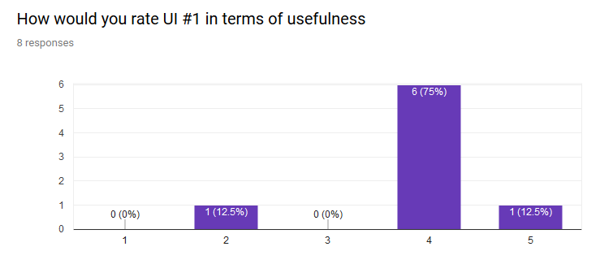

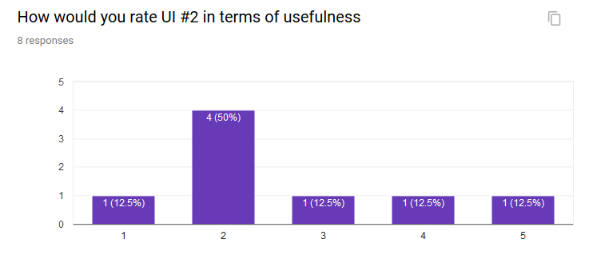

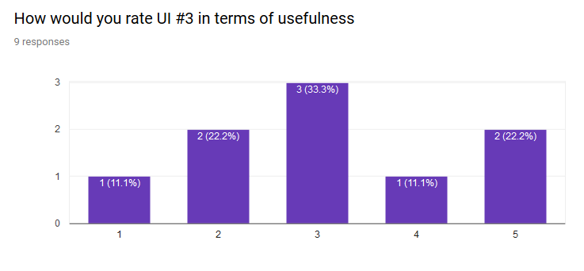

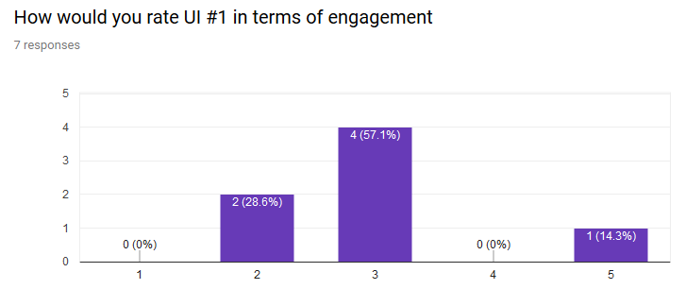

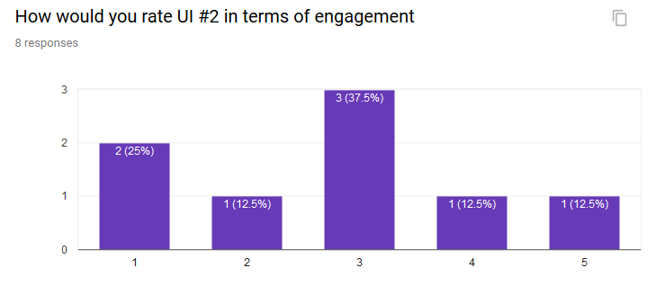

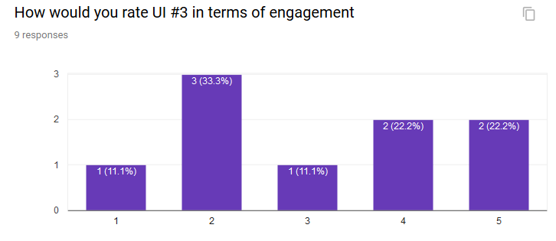

The survey results indicate that UI 1 is seen as being the most useful and UI 3 being a very close second in this respect. In terms of engagement, UI 3 is seen as the most engaging with the other 2 being very close in second place. These results are helpful however none of the Uis stand out as having overwhelmingly positive feedback in either category. When looking at engagement, the results are especially inconclusive as the results were spread across all of the ratings and none stood out as definitively positive or negative. As such it is essential to look at individual user feedback to determine the best UI.

Looking at the question of ‘what aspects of the UI did you like’ we can see that three individuals found this UI to be informative and detailed, there were also two individuals who found that the link to helpful resources for mental wellness were positive aspects of the UI. The positive feedback for UI 2 identifies clarity and layout as positive aspects, however there were two individuals who indicated that nothing stood out as positive about this UI, which suggests that the UI may not be the strongest candidate. The positive feedback for UI 3 indemnifies that this iteration uses a scale for mood rather than just good or bad, the game is also highlighted by two evaluators. Much like UI2 there are two individuals who did not find this UI to be very strong, however there does seem to be a greater emphasis on positive feedback as compared to UI 2.

Looking at the question of ‘what aspects of the UI did you not like’ there are four individuals who feel that this UI is cluttered, the other stand out comment is that the UI appears to be quite boring, which may result in lower engagement. UI 2’s feedback suggests that this UI may not be very professional and may in fact be a bit childish in its appearance, there are also multiple individuals who feel that this UI does not provide information, overall this UI appears to have quite a few issues in its current state. The feedback for UI 3 suggests that the layout for this UI may be a bit dated and not very interesting, some individuals also feel that this UI may be a bit lacking in providing a positive and welcoming feeling, the graph is also noted as being quite unintuitive.

Finally, the comments and general feedback for the UIs will help us fully understand the previous results and decide which UI we should pursue for further development. The feedback for UI one has a theme of having a lot of information, some do find this to be a bit too much while others actually like this. The feedback also identifies that this UI is not very visual and may benefit from visual elements, specifically for mood tracking. Overall this UI could use some minor changes and refinement to be more useful and intuitive, however it does appear to be a strong contender. The second UI has a recurring theme of lacking functionality, while being a more personable and friendlier design. The usage of space for this UI may not be optimal in the current state as identified by multiple individuals. One individual also identified that there was only one game, and that they would like to see more, this could be an opportunity for future development. Overall the feedback for UI 2 suggests that while this design may be more visually appealing, it is lacking in functionality, and the individuals who provided feedback favor function over form. The feedback for UI 3 is quite mixed, some individuals feel that this may the best UI of the 3, while others feel that it is very lacking. Specifically, some individuals feel that the UI is lacking in visual appeal and functionality. Some individuals have identified that they like the game aspect of this UI which is both a risk and opportunity, while the game may bring users in, we would have to balance this with the prevalence of the game to the other aspects of the app. One individual identified that a combination of this UI and the first, with a focus on a concise design and more information may be the best solution.

Final UI decision:

Using all of the above feedback and weighing the goals outlined in our outcomes as well as the MVP the best UI does in fact appear to be a combination of the first and second UI. The detailed information utilized in the first UI is an essential aspect of the UI and a key reason for selecting it as the framework for the UI we will develop into our prototype. The third UI has a lot more nuance to the value it brings to the table, specifically this UI is very concise and provides feedback to the user in a visual and meaningful manner. The final UI will utilize a single game for our 1.0 release and provide a fun and simple escape for our users. The final UI will also utilize graphs and a slider for mood tracking as this provides more detailed feedback to users rather than a binary mood tracker. The UI will use smooth and meaningful transitions between the different components to provide a comfortable and inviting user experience.